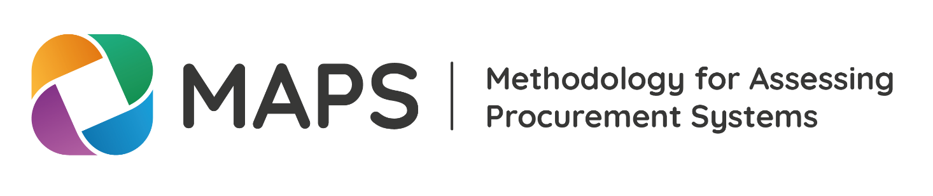
Checklist - Quality review
version 2.0 - UPDATED NOVEMBER 2022

INTRODUCTION
MAPS includes a quality assurance process that ensures that all assessments are methodologically complaint, technically sound, and in line with latest international good practices.
The quality assurance process consists in a methodological review by the MAPS Secretariat and a technical review by the Assessment Technical Advisory Group, which is composed of experts in public procurement from the MAPS Network.
Both the concept note and the assessment report goes through the quality assurance process.
PURPOSE
This template provides a checklist that assessors and lead institutions can use to ensure that they are well prepared for the quality assurance process.
The checklist consists of questions that will certainly be looked at during quality assurance. Note that the list is not exhaustive. Particularly for the technical review done by the ATAG, questions will depend on given assessment.

Checklist: Quality Review
CONCEPT NOTE
Step | Yes/NO
Has a concept note been prepared, gone through quality assurance, and been approved by the MAPS Secretariat and the ATAG before the start of the assessment?
Does the concept note follow the Concept Note Template?
Have data sources in general and quantitative indicators in particular been considered in the concept note?
Has the relevant government committed to publishing the assessment report?

GOVERNANCE
Step | Yes/NO
Has an Assessment Steering Committee (ASC) been established?
Does the ASC include private sector representatives?
Does the ASC include civil society representatives?
Has a national coordinator been appointed from the relevant country authorities?
Does the national coordinator have resources (people) at their disposal for fulfilling their responsibilities who are dedicated to the assessment?

ASSESSMENT AND ASSESSMENT REPORT
Step | Yes/NO
Has the Assessment Report Template been used?
Does the report include an executive summary targeted at decision-makers?
Does the executive summary include the compliance matrix from the Assessment Report Template?
Does the report include an analysis of country context?
Has discussions of data availability been included in the report?
Have the assessment of all indicators been included in the report?
Have all minimum quantitative indicators been calculated, and if not has a reason been provided for this?
Have all substantive gaps been described and classified according to risk?
If any red flags have been assigned, has the reason for assigning them been explained for each?
Have recommendations been made that address all substantive gaps?
Has validation been carried out including with private sector and civil society representation?
Does the report include a description of the validation and its results on a general level?
Has a strategic action plan been included in the report, taking into account risks, government priorities, and timeline?
Have all appropriate annexes been included in the report, as detailed in the Assessment Report Template?
Has the indicator matrix been included as an annex in the report?
Has the indicator matrix been filled out fully and correctly according to the Indicator Matrix Template, with analysis (qualitative, quantitative, gaps) and conclusion for every single assessment criterion, as well as red flags and recommendations where applicable?
Has formatting been harmonized across the assessment report, including fonts, font sizes, headers, lists, tables, visualisations?
Has terminology been harmonized across the assessment report (e.g. e-Procurement or e-GP?) and does it correspond to the MAPS Glossary?
AN

QUALITY ASSURANCE OF THE ASSESSMENT REPORT
Step | Yes/NO
Has the assessment report been submitted to the MAPS Secretariat for quality assurance?
Have all comments from the MAPS Secretariat and the ATAG been addressed?
Has a revised report been submitted to the MAPS Secretariat, including an overview of how comments were addressed?
D ASSESSMENT T

