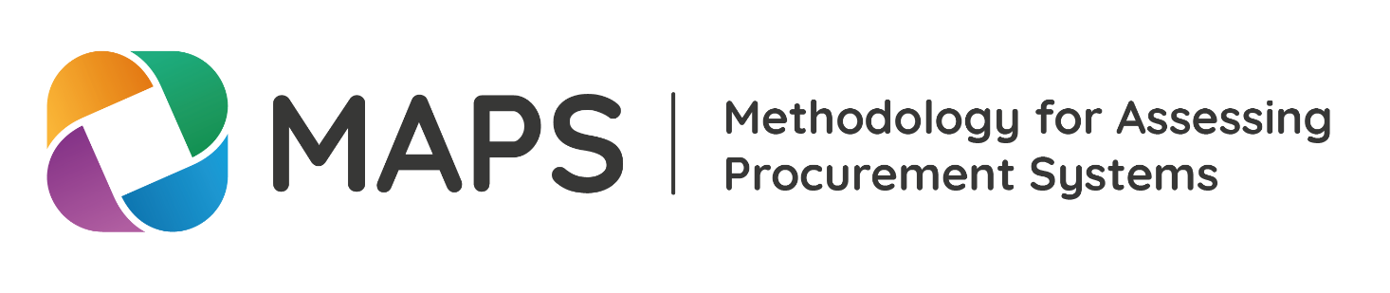
Checklist: Stakeholders
2018
This document provides an overview or checklist of types of stakeholders that usually have a stake in a MAPS assessment. The list can serve to build the agenda for interviews in country, be it for a self-assessment or for the assessment team. The list has to be seen in close relation with the analysis of country context. The analysis of country context will likely add information to this list; vice versa will benefit from working through this list to ensure comprehensiveness. This list is always highly context-specific: Some institutions might not be in place in certain countries individually; however, the function might be allocated to an institution that could be involved.
Type of function or institution | Name of Institution in the country incl. contact information | (If applicable: time slot in interview agenda)
Authority in charge of the assessment (typically the regulatory authority, ministry, or centre of government)
Institution in charge of the normative/regulatory function for public procurement
Administrative/judicial review (appeals) body for procurement
Selected number of procuring entities including state owned enterprises (selection can be made based on regional or thematic focus of assessment)
Centralized procurement body, if any
Authorities responsible for budgeting, payment and financial procedures
Authorities in charge of internal and external controls and audits
Anti-corruption agencies
Competition bodies, e.g. Competition Commission
Authority responsible for Public Private Partnerships
Public Service Commission
Training institutions
Procurement professional body
Representatives of private sector
Representatives of civil society
Research institutions, Academia
Media
International partners engaged in procurement in the country (if applicable and not already otherwise involved in the assessment, e.g. through the Technical Advisory Group)

