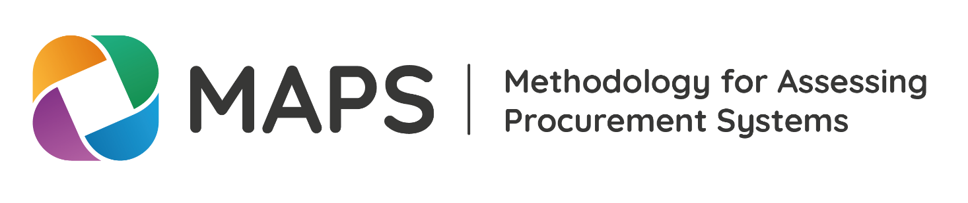

Template: Request Letter

2018



Country Seal/Header

Date

Recipient

Title

Company

**Street Address  
City, ST ZIP Code

Dear Recipient:

This letter serves to inform you that [Country] intends to conduct a Methodology for Assessing Procurement Systems (MAPS) assessment. [*Provide the context for public procurement in the country, including any past MAPS or similar assessments. In addition, provide the strategic value or main reasons to conduct a MAPS assessment at this time. If available, please provide an indication on timeframes for the assessment.*]

[Country] formally requests the participation of [Lead Institution/Secretariat] in initiating and coordinating this exercise. [Lead Government Agency] will act as the Lead Government Agency for this activity for the Government of [Country]. [Official Point of Contact for Lead Government Agency] will act as the official point of contact.

Sincerely,

[Government Official]\*

\*This request must be received from a Government official with authority to commit the Government.